Or 3ABS LAWN AHOW SCHEDULE
ABS 69th ANNIVERSARY CARNIVAL SHOW
For Young, Juvenile and Nestfeathers Budgies,
Plus Special Community Awards.
Sunday 18th October 2026

Proudly supported by Mars Birdcare
- The Queensland Finch Society Inc.: Applied Nutrition - TummyRite
- African Love Birds and Foreign Parrot Society of Queensland Inc.
- Queensland Council of Bird Societies Inc.: Noah’s Animal Health
- Red Factor & Coloured Canary Club Qld Inc.: Bendigo Community Bank.
- Gold Coast Aviary Bird Association Inc.: Australian Bird Keeper ABK.:
- Canary and Cage Bird Federation of Australia: Sth Qld Bird Breeders Inc.
- Live Radio Broadcast from 101FM 9am -1pm
Each Club listed above will be having a Show or Display and Sale Day
VENUE: Beenleigh Show Grounds Hall
Exit 35 off the Pacific Highway, Enter New Show Hall from Showgrounds Drive, Off Kent Street Beenleigh, Qld.4207.
(HEAPS OF PARKING AVAILABLE ON THE DAY)
www.absbudgieclub.org.au
INVITATION TO ALL MEMBERS OF THE FANCY TO ATTEND

BRING ALONG YOUR YOUNG BUDGIES, JEUVENILES & NESTFEATHERS – CASH & TROPHIES FOR ALL SECTIONS – JUNIOR, NOVICE, INTERMEDIATE, OPEN & SPECIAL JUNIOR AWARDS, PLUS
FAMILY PET BUDGIE & DECORATED CAGE PRIZES
ENTRIES are FREE in this SHOW.
Call Cheryl Wilson 32094921 or email babybird1973a@outlook.com Gavin Tilse 0428 553 938 or email gavintilse@hotmail.com or Wayne Robinson 32074940 or 0407037522 email budgie13@netspace.net.au with your entries. Text & Email entries are welcomed.
Entries close on Monday the 12/10/26 at 8:30pm.
A GREAT SOCIAL DAY, RELAX AND ENJOY A CHAT AMONGST FELLOW BIRD FANCIERS, COMMUNTY GROUPS & BUSINESSES, A COLD DRINK, WONDERFUL CAFÉ ABS LUNCH, LOTS OF FUN FOR EVERYONE, COME ALONG FOR A FUN DAY OUT
Especially FUN for Juniors and the Whole Family.
BIRDS FOR SALE ALSO WELCOME
JUDGING STARTS 9.30AM – FREE MORNING TEA THEN LUNCH –
Multi Draw Raffle on the day, Golden Cob Seed, TummyRite, Bunnings Vouchers, Big Gun Gift Voucher, Special Wooden decorated Cutting Board, Plus, $1 per ticket or 6 for $5.

Our Trade Table will be fully stocked with all your Budgerigar Stud requirements on the day at very reasonable prices.

Displays and Shows from all our friends in bird clubs from around the South-East Queensland. Come and make new friends & see some superb birds at the show.
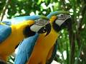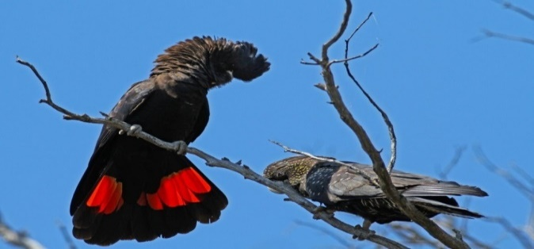

SCHEDULE FOR NESTFEATHER, JUVENILE AND YOUNG BUDGERIGAR SHOW

Date: Sunday 18th October 2026

Venue: Beenleigh Show Grounds Hall Exit 35 off the Pacific Highway, Enter New Show Hall from Showgrounds Drive, Off Kent Street Beenleigh, Qld.4207.

Entries: Will close at 8.30pm, Monday 12th of October. Entries must be in the hands of the following ABS members by that time. No late entries will be accepted.
Contact: Cheryl Wilson on 32094921 or 0432 294 337, babybird1973a@outlook.com
Gavin Tilse 0428 553 938 or Wayne Robinson on 0407 037 522 budgie13@netspace.net.au Text or email entries are welcomed.
If emailing entries, please ask for confirmation. Emergency number on the day 0407 037 522, 0432 294 337 or 0400 293 678

Entry Fee: Entry is FREE for this Show. Points for elevation are on offer at this show.
Staging: All exhibits must be staged between 8.00 and 9.00am on the day of the show.
Rings: Young birds must bear the registered number or code of the exhibitor on a closed 2025 Black Ring. Juveniles 2026 Green Ring ANBC approved ring. N/F will be a 2026 Green Ring. Only one closed metal ring from any recognised society is permissible. Spot ring checks may be made.

This is a unisex show for Nestfeathers, please use cock bird class numbers.

Labels: To be affixed to bottom right hand corner of cage. Class labels and exhibitors’ portion will be posted at a cost of $1.10 or collected on Show Day. Please be aware of the postal timeframes. Entry Labels can also be collected on the morning of the show. Please check them.
Rules: The show will be conducted under the rules of the Australian Budgerigar Society Inc. as interpreted by the Show Committee (ie SQBBA rules). All exhibitors acknowledge acceptance of these rules as a condition of entry. Rules as per the SQBBA. Purchased bird cannot be shown.
Cages: Only show cages which meet the A.N.B.C. show cage specification will be accepted. Any birds in dirty, marked or damaged cages will not be considered for awards. The Show Manager will inspect all cages prior to judging.
Seed: All Show Cages will contain at the discretion of the exhibitor a seed mixture suitable for budgerigars or Millet Sprays. No distinguishing seed such as sunflower seed to be used.
Reclassification: All Junior and Novice exhibits will be reclassified at entry.
Judging: Judging will commence at 9.30 am sharp. The judge’s decision will be final in all matters of merit.
Exhibits: All birds will be considered the property of the Society during the period of the show and they must not be touched or taken away without the permission of the Show Manager. All birds entered are at the sole risk of the exhibitor and the Society will not be held responsible for loss or injury.
Awards: Presentation of Awards will take place at approximately 1 p.m.
Removal: Removal of birds shall be directly following presentation. All birds shall be gathered off the staging by the exhibitors and when all birds are removed, and the committee is satisfied that everyone has their birds it will be announced that all can leave. During the show, all exhibits are in the custody of the chief steward.
Selling: Exhibitors are encouraged to bring along sale birds which will not be judged. Birds entered in this section, 10% of selling price going to the Society. Maximum of four birds per cage of varying colour and sex. Selling to the general public to commence from 8.30am on a “first in first served basis”. Seed & water to be provided.

Morning Tea: A Scrumptious FREE Morning Tea will be provided free to all judges, exhibitors and stewards by Café ABS.

Lunch: A seated Café ABS Lunch and Dessert will be available for $8. Please purchase tickets just after arrival to assist in catering for our Carnival show.
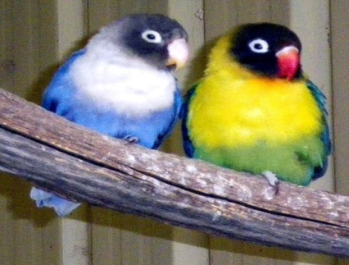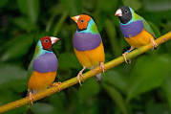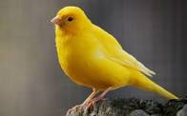
ABS Carnival Show Trophy List
Champion Young Bird of Show Trophy Plus $40.00
Champion Young Bird Opposite Sex of Show Trophy Plus $40.00

Champion Juvenile Bird of Show Trophy Plus $40.00
Champion Juvenile Bird Opposite Sex of Show Trophy Plus $40.00

Champion Nestfeather of Show Trophy Plus $40.00
Champion Nestfeather Reserve of Show Trophy Plus $40.00

Junior Champion Young Bird of Show Trophy Plus $40.00
Junior Champion Nestfeather of Show Trophy Plus $40.00

Champion Young Budgerigar – Open – Intermediate- Novice – Junior – Trophy

Opposite Sex Champion Young Budgerigar - Open – Intermediate – Novice – Junior - Trophy

YOUNG BIRD AWARDS IN OPEN – INTERMEDIATE – NOVICE– JUNIOR

Best Normal $10 Bunnings GV Trophy
Best Sex-linked $10 Bunnings GV Trophy
Best Dominant $10 Bunnings GV Trophy
Best Lesser Variety $10 Bunnings GV Trophy

Champion Juvenile Budgerigar – Open – Intermediate- Novice – Junior - Trophy
Opposite Sex Champion Juvenile Budgerigar - Open – Intermediate – Novice – Junior - Trophy

JUVENILE BIRD AWARDS IN OPEN – INTERMEDIATE – NOVICE– JUNIOR

Best Normal $10 Bunnings GV Trophy
Best Sex-linked $10 Bunnings GV Trophy
Best Dominant $10 Bunnings GV Trophy
Best Lesser Variety $10 Bunnings GV Trophy

Champion Nestfeather Budgerigar – Open – Intermediate- Novice – Junior - Trophy
Reserve Champion Nestfeather Budgerigar - Open – Intermediate – Novice – Junior - Trophy

NESTFEATHER AWARDS IN OPEN – INTERMEDIATE – NOVICE– JUNIOR

Best Normal $10 Bunnings GV Trophy
Best Sex-linked $10 Bunnings GV Trophy
Best Dominant $10 Bunnings GV Trophy
Best Lesser Variety $10 Bunnings GV Trophy

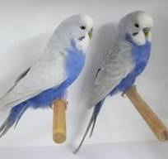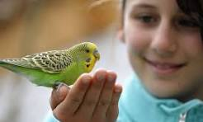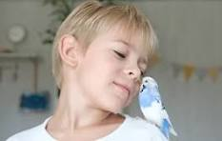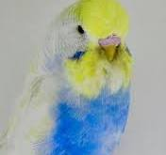

Special ABS Family Community Show Awards List

Best Decorated Cage Trophy
Best Pet Budgie Trophy

SQBBA COLOUR SCHEDULE
Effective 1st January 2021
COCKS |  |  |  |  |  |  |  |  |  |  |  | HENS
No | A/A | Old | Y/B | N/F | J | VARIETY | COLOUR | A/A | Old | Y/B | N/F | J | No
1 |  |  |  |  |  | Normal | Light Green |  |  |  |  |  | 2
3 |  |  |  |  |  | Normal | Dark or Olive Green |  |  |  |  |  | 4
5 |  |  |  |  |  | Normal | Grey Green |  |  |  |  |  | 6
7 |  |  |  |  |  | Normal | Sky Blue |  |  |  |  |  | 8
9 |  |  |  |  |  | Normal | Cobalt, Mauve, Violet Sky, Violet Mauve |  |  |  |  |  | 10
11 |  |  |  |  |  | Normal | Violet |  |  |  |  |  | 12
13 |  |  |  |  |  | Normal | Grey |  |  |  |  |  | 14
15 |  |  |  |  |  | Yellowface Normal | Blue Series |  |  |  |  |  | 16
17 |  |  |  |  |  | Australian Golden Face Normal (Double Factor only) | Blue Series |  |  |  |  |  | 18
19 |  |  |  |  |  | Australian Golden Face Normal (Single Factor only) | Blue Series |  |  |  |  |  | 20
21 |  |  |  |  |  | Lutino | Yellow |  |  |  |  |  | 22
23 |  |  |  |  |  | Albino (incl Y/face & Golden Face D/F) | White |  |  |  |  |  | 24
25 |  |  |  |  |  | Cinnamonwing (incl Y/face & Golden Face D/F) | Green or Blue Series |  |  |  |  |  | 26
27 |  |  |  |  |  | Lacewing (incl Y/face, Golden Face D/F & Opaline) | Green or Blue Series |  |  |  |  |  | 28
29 |  |  |  |  |  | Opaline Normal (incl Y/face & Golden Face D/F) | Green or Blue Series |  |  |  |  |  | 30
31 |  |  |  |  |  | Opaline AOSV (incl Y/face, Golden Face D/F, Blackeye, Dilute, Clearwing, Greywing, Cinnamon) | Green or Blue Series |  |  |  |  |  | 32
33 |  |  |  |  |  | Clearbody Normal (incl Y/face & Golden Face D/F & Opaline) | Green or Blue Series |  |  |  |  |  | 34
35 |  |  |  |  |  | Dominant Pied (incl D/Factor, Y/face, Golden Face D/F, Greywing, Cinnamon, Opaline, Fallow & Spangle) | Green or Blue Series |  |  |  |  |  | 36
37 |  |  |  |  |  | Spangle Normal (Incl Y/face & Golden Face D/F, Excl Pied & all in Spangle AOSV) | Green or Blue Series |  |  |  |  |  | 38
39 |  |  |  |  |  | Spangle AOSV (incl Greywing, Cinn, Opal & Fallow & combinations & incl Y/Face, Golden Face D/F) | Green or Blue Series |  |  |  |  |  | 40
41 |  |  |  |  |  | Spangle Double Factor - (incl Y/face & Golden Face D/F) | Green or Blue Series |  |  |  |  |  | 42
43 |  |  |  |  |  | Australian Whitecap - Single & Double Factor  including all varieties in blue series except Yellowface, Goldenface and Crest (Any type). | Blue Series |  |  |  |  |  | 44
45 |  |  |  |  |  | Greywing Normal (excl Opal, Cinn) (incl Y/face & Golden Face D/F) | Green or Blue Series |  |  |  |  |  | 46
47 |  |  |  |  |  | Clearwing Normal (excl Opal, Cinn) (incl Y/face & Golden Face D/F) | Green or Blue Series |  |  |  |  |  | 48
49 |  |  |  |  |  | Fallow (incl Y/face, Golden Face D/F, Greywing &Opaline) | Green or Blue Series |  |  |  |  |  | 50
51 |  |  |  |  |  | Blackeye Self Normal (excl Opaline) (incl Y/face & Golden Face D/F) | Green or Blue Series |  |  |  |  |  | 52
53 |  |  |  |  |  | Dilute Normal (excl Opaline) (incl Grey Yellow/White, Y/face & Golden Face D/F) | Green or Blue Series |  |  |  |  |  | 54
55 |  |  |  |  |  | Danish Recessive Pied (incl Y/face, Golden Face D/F,  Greywing, Cinnamonwing, Opaline, Fallow & Spangle) | Green or Blue Series |  |  |  |  |  | 56
57 |  |  |  |  |  | Dark Eyed Clear (incl Y/face & Golden Face D/F) | Green or Blue Series |  |  |  |  |  | 58
59 |  |  |  |  |  | Crested ASV (incl Y/face, Golden Face D/F and Whitecap) | Green or Blue Series |  |  |  |  |  | 60
61 |  |  |  |  |  | Saddleback ASV (incl Y/face & Golden Face D/F) | Green or Blue Series |  |  |  |  |  | 62
63 |  |  |  |  |  | Darkwing ASV (incl Y/face & Golden Face D/F) | Green or Blue Series |  |  |  |  |  | 64
65 |  |  |  |  |  | AOV Non Standardised Variety (incl Y/face & Golden Face) | Green or Blue Series |  |  |  |  |  | 66
67 |  |  |  |  |  | Variable Class – | As per ANBC Standard |  |  |  |  |  | 68
* When placing entries please ensure you state whether Any Age, Old, Young, Nestfeather or Juvenile birds are being entered.
* Green Series includes Light, Dark, Olive and Grey Green.
* Blue Series includes Sky Blue, Cobalt, Mauve, Violet and Grey.
* All classes are in accordance with the ANBC Standard and Matrix - 2021
* Multiple factor birds exist in many combinations. Therefore, if the schedule does not list a certain colour/variety combination then these birds will go into the AOV and Non Standardised classes. Refer ANBC Standard colour matrix for combinations.
* Variable class to be nominated on the Show Schedule by each club as required.
* Only Normal Goldenface Double Factor (D/F) are eligible for SQ Gold Breeder Award
D/F after Golden Face in other varieties = Double Factor

Our Trade Table will be operating and if you require products prior to the show please contact Wayne Robinson on 3207 4940 or 0407037522 so he can order the stock as required and have it there on the day for you to collect.
Directions for getting here
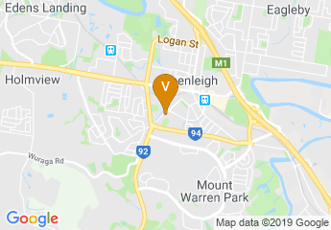

Beenleigh Show Grounds Hall
Exit 35 off the Pacific Highway Enter New Show Hall from Showgrounds Drive, Off Kent Street, Beenleigh, QLD 4207
For more information contact: Wayne Robinson PH 0407 037 522 Gavin Tilse
PH 0428 553 938, Cheryl Wilson PH 0432 291 337

Without the continued support from our members, supporters, and friends of our great club the Australian Budgerigar Society Inc. shows like the one you are about to attend may not exist. Thank you from our committee and wider club membership for your continued unwavering commitment to events that we host.
Once again “Thank You” from all of us at ABS Inc.
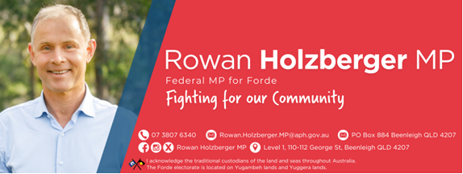
A Special Thank You to our Co Patron Federal Member for Forde Mr. Rowan Holzberger MP for printing our monthly Budgie Buzz Bulletin and other documents when required. Mr. Rowan Holzberger is located at Level 1, 110-112 George Street, Beenleigh. You can contact him on 3807 6340.
THANK YOU to all the clubs, our friends in the bird fancy that made today possible, your support is invaluable, amazing, and fantastic. We look forward to your ongoing support with the Carnival Show in 2027.

