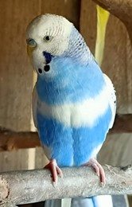
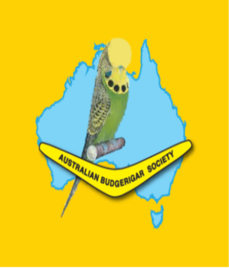
THE AUSTRALIAN BUDGERIGAR SOCIETY
Discover the vibrant world of budgerigars with hands-on activities and engaging presentations for all ages. Whether you're a seasoned bird enthusiast or simply curious, there's something for everyone to enjoy at our community event.
“YEAR OF THE JUNIOR”
SCHOOL HOLIDAY FEATHERS FUN FEST 1st OCTOBER 2026 10am – 2pm
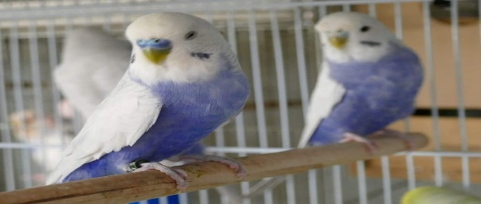
1 PLANTATION ROAD BEENLEIGH
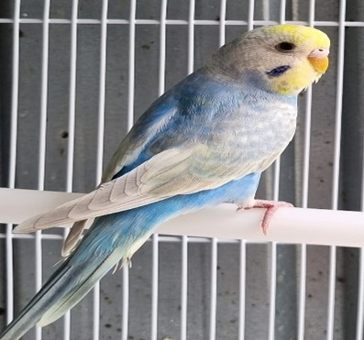
Join Us for a FREE Budgie Day Out for Families, Children and Friends on the school holidays
- Budgie Displays all colours
- Hold and Handle a Budgie
- Learn about keeping Budgies
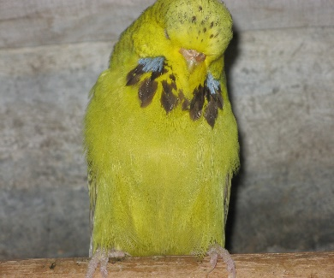
- Big Screen Budgie Movies
- Budgies for Sale
- Free Morning Tea & Free Pizza Lunch
- Free Junior Club Membership
For More Information and details contact
Wayne Robinson M 0407 037 522 or Cheryl Wilson M 0432 291 337

