Moreton Budgerigar
Association

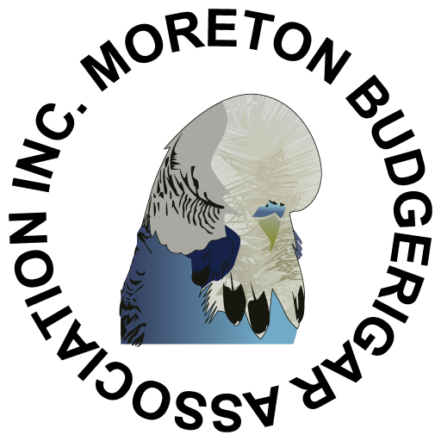

2026 Spring Show
Strathpine Community Centre
Tom Petrie Room
Mecklem St, Strathpine

Sunday 13th September

Moreton Budgerigar Association
NEST FEATHER, YOUNG and OLD BIRDS Show
Sunday 13th September 2026

VENUE | Strathpine Community Centre  Tom Petrie Room  Mecklem St. Strathpine
TYPE OF SHOW | Young, Old Birds & Nestfeathers in Open, Intermediate, Novice.
SHOW RULES | As per rules of SQBBA Inc.
ENTRIES | Online Entries https://mbaspring.fairwire.com/  D Ganzer – 07-54286838 / 0402 161 845  Carlisle Wyllie – wylliec7@bigpond.com  Entries close at 8.00 p.m. on Monday 7th September 2026.  LODGED
ENTRY FEE | $1 per bird (all entries must be paid for) maximum $20  priority postage $3 or express postage $9.
CAGES | All exhibits to be staged in ANBC recognized show cages, powder coated cage fronts. At the discretion of the Show Committee any bird in a dirty or badly presented cage may be disqualified from being judged.
CLASS LABELS | To be affixed to right hand side bottom corner of cage.
FLOOR COVERING | MILLET SPRAYS as per SQBBA show rules.
RING NUMBERS | If a parent society has issued MBA Inc. with a current ring list, ring numbers need not be declared on entry form. It is the responsibility of exhibitors to ensure that a ring list has been supplied. Spot ring checks may be made.
NEST FEATHER | Must be rung with a 2026 (green) closed ring and must be owned and bred by the exhibitor. Unbroken cap feathering and will be judged as unisex.
YOUNG 2025 black | Must be rung with a 2025 (black) closed ring and must be owned and bred by the exhibitor
YOUNG 2026 green | Must be rung with a 2026 (green) closed ring and must be owned and bred by the exhibitor
OLD | Birds in this class must be owned and bred by the exhibitor and will be judged as unisex
 | No purchased birds can be shown. Split rings are not permitted.
STAGING | All birds to be staged between 8.30 a.m. and 9.30 a.m.
JUDGING | To commence at 10.00 a.m. and will be to the Australian standard.
LUNCH | Will be available at a nominal cost.
PRESENTATION | Immediately following lunch.
REMOVAL OF BIRDS | Immediately after presentation. During the show all exhibits will be in the custody of the Chief Steward. All reasonable care but no responsibility will be taken. No birds are to be removed without the authority of the Chief Steward.
BIRD SALE | Birds for this section may be entered on the morning of the show.  A maximum of 4 birds of different colours per cage. A commission of 10% of the selling price will be charged. Please affix class label to cage stating your name and the variety, sex and price of birds entered.

TROPHY LIST
Champion YOUNG 2025 Bird of Show | $50 Cash
Champion YOUNG 2025 Bird Opposite Sex of Show | $50 Cash
Champion YOUNG 2026 Bird of Show | $50 Cash
Champion YOUNG 2026 Bird Opposite Sex of Show | $50 Cash
Champion NEST FEATHER of Show | $25 Cash
Champion OLD Bird of Show | $25 Cash
Best of Show Darkwing, Saddleback & Rainbow  (Old / Young 2025 / Young 2026) (Classes 61-62) | $25 Cash
Junior Exhibitor Encouragement Award | Engraved Trophy

To be awarded in Open, Intermediate and Novice
Best YOUNG 2025 Cock | $15 Cash
Best YOUNG 2025 Hen | $15 Cash
Best YOUNG 2026 Cock | $15 Cash
Best YOUNG 2026 Hen | $15 Cash
Best NEST FEATHER | $15 Cash
Best OLD Bird | $15 Cash

Nest Feather | Open | Intermediate | Novice
Best Normal Variety (Classes 1-20) | $10 Cash | $10 Cash | $10 Cash
Best Sexlinked Variety (Classes 21-34) | $10 Cash | $10 Cash | $10 Cash
Best Dominant Variety (Classes 35-44) | $10 Cash | $10 Cash | $10 Cash
Best Recessive & Other Variety (Classes 45-64) | $10 Cash | $10 Cash | $10 Cash
Young 2025 Black ring | Open | Intermediate | Novice
Best Normal Variety (Classes 1-20) | $10 Cash | $10 Cash | $10 Cash
Best Sexlinked Variety (Classes 21-34) | $10 Cash | $10 Cash | $10 Cash
Best Dominant Variety (Classes 35-44) | $10 Cash | $10 Cash | $10 Cash
Best Recessive & Other Variety (Classes 45-64) | $10 Cash | $10 Cash | $10 Cash
Young 2026 Green ring | Open | Intermediate | Novice
Best Normal Variety (Classes 1-20) | $10 Cash | $10 Cash | $10 Cash
Best Sexlinked Variety (Classes 21-34) | $10 Cash | $10 Cash | $10 Cash
Best Dominant Variety (Classes 35-44) | $10 Cash | $10 Cash | $10 Cash
Best Recessive & Other Variety (Classes 45-64) | $10 Cash | $10 Cash | $10 Cash
Old Bird | Open | Intermediate | Novice
Best Normal Variety (Classes 1-20) | $10 Cash | $10 Cash | $10 Cash
Best Sexlinked Variety (Classes 21-34) | $10 Cash | $10 Cash | $10 Cash
Best Dominant Variety (Classes 35-44) | $10 Cash | $10 Cash | $10 Cash
Best Recessive & Other Variety (Classes 45-64) | $10 Cash | $10 Cash | $10 Cash
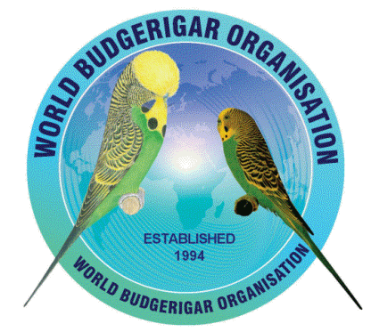
World Budgerigar Organisation Rosettes for
Best Young 2025 Bird of Show
Best Young 2025 Bird Opposite Sex of Show
Best Old Bird of Show
Best Old Bird Opposite Sex of Show

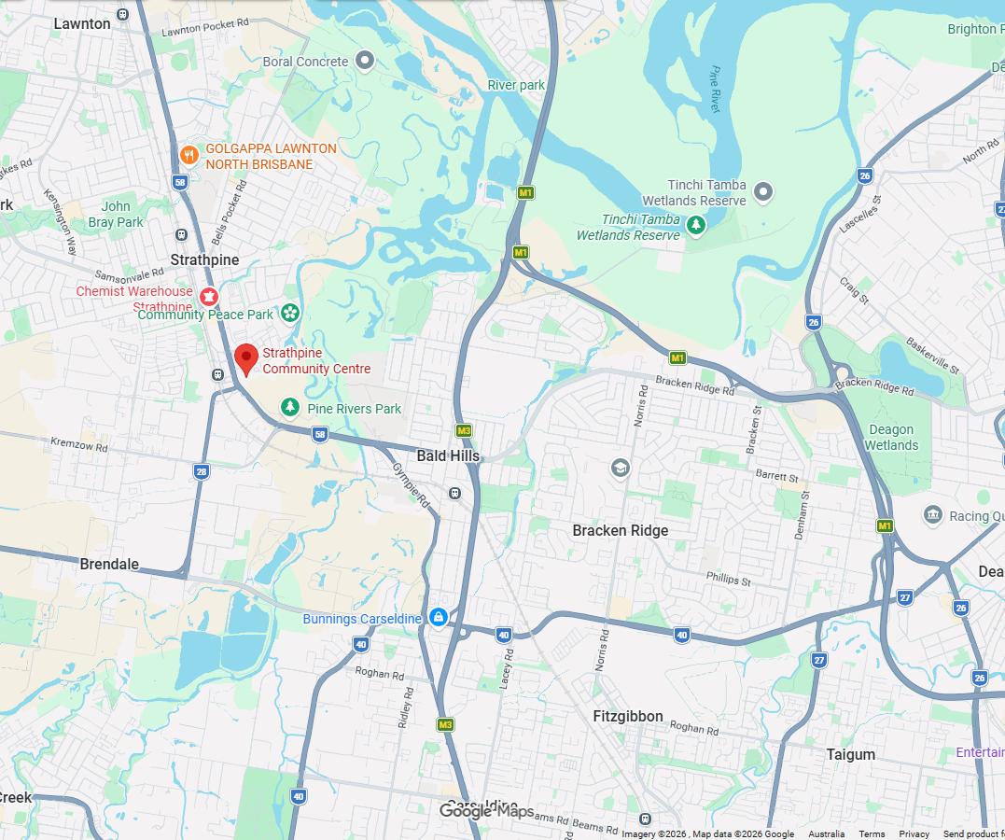

Moreton would like to thank all the members for their help and the following people for their donations to the show:-
Morayfield Produce Supplies
Noah’s Avian Health
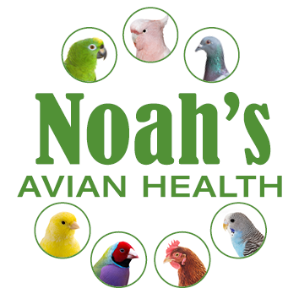

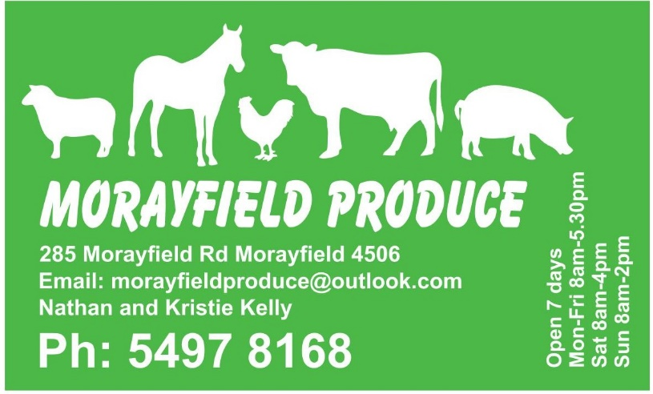

ONLINE ENTRIES
To enter online go to https://mbaspring.fairwire.com/ and register.
If you show as a partnerships, you can register as a company/team, this allows you to provide your partnership name.
You will then be able to add your entries and how many lunch tickets you would like.
SQBBA COLOUR SCHEDULE
Effective August 2025
No | Unisex | Unisex | COCKS |  | VARIETY |  | COLOUR |  | HENS
No | N/F | Old | Young  2025  Black | Young  2026  Green |  |  |  |  | Young  2025  Black | Young  2026  Green | No
1 |  |  |  |  |  | Normal |  | Light Green |  |  | 2
3 |  |  |  |  |  | Normal |  | Dark or Olive Green |  |  | 4
5 |  |  |  |  |  | Normal |  | Grey Green |  |  | 6
7 |  |  |  |  |  | Normal |  | Sky Blue |  |  | 8
9 |  |  |  |  |  | Normal |  | Cobalt, Mauve, Violet Sky, Violet Mauve |  |  | 10
11 |  |  |  |  |  | Normal |  | Violet |  |  | 12
13 |  |  |  |  |  | Normal |  | Grey |  |  | 14
15 |  |  |  |  |  | Yellowface Normal |  | Blue Series |  |  | 16
17 |  |  |  |  |  | Australian Golden Face Normal (Double Factor only) |  | Blue Series |  |  | 18
19 |  |  |  |  |  | Australian Golden Face Normal (Single Factor only) |  | Blue Series |  |  | 20
21 |  |  |  |  |  | Lutino |  | Yellow |  |  | 22
23 |  |  |  |  |  | Albino # |  | White |  |  | 24
25 |  |  |  |  |  | Cinnamonwing Normal # |  | Green or Blue Series |  |  | 26
27 |  |  |  |  |  | Lacewing Normal & Opaline # |  | Yellow or White |  |  | 28
29 |  |  |  |  |  | Opaline Normal # |  | Green or Blue Series |  |  | 30
31 |  |  |  |  |  | Opaline AOSV # (Cinnamon, Blackeye, Greywing, Clearwing & Dilute) |  | Green or Blue Series |  |  | 32
33 |  |  |  |  |  | Clearbody Normal & Opaline # |  | Green or Blue Series |  |  | 34
35 |  |  |  |  |  | Dominant Pied # (incl Cinnamon, Greywing, Opaline, Fallow & Spangle) |  | Green or Blue Series |  |  | 36
37 |  |  |  |  |  | Spangle Normal # |  | Green or Blue Series |  |  | 38
39 |  |  |  |  |  | Spangle AOSV # (incl Greywing, Opaline, Cinnamon & Fallow & combinations) |  | Green or Blue Series |  |  | 40
41 |  |  |  |  |  | Spangle Double Factor # |  | Green or Blue Series |  |  | 42
43 |  |  |  |  |  | Australian Whitecap - Single & Double Factor including all varieties in blue series except Yellowface, Goldenface & Crest |  | Blue Series |  |  | 44
45 |  |  |  |  |  | Greywing Normal # |  | Green or Blue Series |  |  | 46
47 |  |  |  |  |  | Clearwing Normal # (excl Opaline, Cinnamon) |  | Green or Blue Series |  |  | 48
49 |  |  |  |  |  | Fallow # (Incl Greywing) |  | Green or Blue Series |  |  | 50
51 |  |  |  |  |  | Blackeye Self # (excl Opaline) |  | Green or Blue Series |  |  | 52
53 |  |  |  |  |  | Dilute Normal # (excl Opaline) |  | Green or Blue Series |  |  | 54
55 |  |  |  |  |  | Danish Recessive Pied # (Incl Greywing, Cinnamon, Opaline, Fallow & Spangle) |  | Green or Blue Series |  |  | 56
57 |  |  |  |  |  | Dark Eyed Clear # |  | Green or Blue Series |  |  | 58
59 |  |  |  |  |  | Crested ASV/ASC as per ANBC Matrix P23 ANBC Standard |  | Green or Blue Series |  |  | 60
61 |  |  |  |  |  | Darkwing & Saddleback ASV (incl Y/f & G/f D/f) & Rainbow |  | As per ANBC Standard |  |  | 62
63 |  |  |  |  |  | AOSV/AOV - Any other Standardised Variety in Combination not recognised by the ANBC Matrix or Non Standardised Variety |  | As per ANBC Standard |  |  | 64
65 |  |  |  |  |  | Variable Class |  | As per ANBC Standard |  |  | 66
All classes are in accordance with the ANBC Standard and Matrix - 2025
# All classes marked as such, Yellowface and Australian Golden Face Double Factor are accepted as per ANBC Standard.

Moreton Budgerigar Association 2026 SPRING SHOW
Exhibitor Name: _______________________________________ Open / Intermediate / Novice
Address:_____________________________________________ Junior
Phone Number: ________________
Post Labels: Yes / No Steward: Yes / No Pencillor: Yes / No

Lunch: Yes / No If Yes, how many: ____

