BENDIGO BANK SPONSORED SHOW
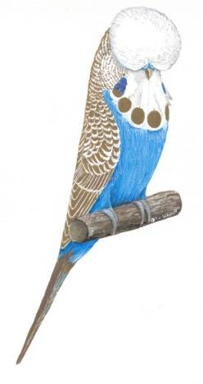
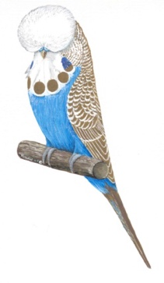
SUNSHINE COAST BUDGERIGAR ASSOC. Inc.

INVITES YOU TO COME ALONG TO OUR

2026 ANNUAL YOUNG BIRD SHOW

(YOUNG BIRD, OLD BIRD, JUVENILE, N’FEATHER)

ON SUNDAY 19th JULY 2026

THIS WILL ALSO BE A SQBBA GOLD BREEDER AWARD SHOW

Venue: Nambour State Primary School Hall on Cnr Coronation Ave and School Street. Enter School Street and turn right into school drop off zone.
Parking on road in front of the Hall. (See map on page 2)

Entries: To be received by MONDAY evening 9.00pm, 13th July 2026,
(Please double check your entries, as incorrect entries will be scratched on show day)
Lodge entries with: (entry form is attached for convenience and for emailing):
Carlisle Wyllie email: wylliec7@bigpond.com
Neale Love on 0421471781 email: rosemount1@bigpond.com
Online entries for SCBA show https://scba.fairwire.com

Colour Schedule: As per SQBBA colour schedule (current colour schedule on page 5 of this schedule)

Staging: All exhibits must be staged between 7.30 & 8.30am on the day of the show.

Entry Fee: Entry $1 (max $20). Club preference is for pick up of stickers on the show day,
However postage is available for $2, if you require stickers to be posted.

Classes: Young Birds: Must be rung with an ANBC approved 2025 Black ring
Old Birds: Must be rung with an ANBC approved ring (pre 2024 Red rung).
Juveniles Must be rung with an ANBC approved 2026 Green ring
Nest Feather Must have Nest Feather traits.
Note: All birds exhibited must be owned and bred by the exhibitor.

Rings: Rings must bear the approved ANBC symbol. Split rings are not permitted.
Show Manager to do spot Ring checks.

Labels: To be affixed to bottom right hand corner of cage. (Please assist by fixing label as high as possible in corner of cage to prevent being covered by staging rail).

Sprays: All Show Cages must contain Millet Sprays/Bobs (No loose seed).
If required, packs of Millet sprays will be available at the show.

Rules: As per rules of SQBBA Inc. (Purchased birds cannot be shown).

Cages: Only show cages which meet the A.N.B.C. show cage specification will be accepted.
Any exhibits in dirty, marked or damaged cages may not be considered for awards.

Judging: Judging to commence at 9.00am. The judge’s decision will be final in all matters of merit.

Exhibits: All birds will be considered the property of the Association during the period of the show
and they must not be touched or removed without the permission of the Show Manager.
All birds entered are at the sole risk of the exhibitor and the Association will not be held responsible for loss or injury.

Support provided by the BENDIGO BANK Cooroy is greatly appreciated
BENDIGO BANK SPONSORED SHOW

Food & Drink: Morning Tea will be supplied (no cost) plus tea & coffee supplied all day. Cold drinks will also be available. Lunch on the Run 11am to 1.00 pm, at a charge of $7.00, please advise numbers on your Entry Sheet or when you call in your entries.

Awards: Presentation will take place when Judging & Awards finalised.

Removal: Removal of birds, directly following award presentation. Show Manager will advise.

Helpers: Anyone able to assist at the show, please advise Keith or Neale. Your help is very much appreciated. We also need helpers to set up staging on Saturday Arvo
Contact Steve if you can help out between about 1pm - 3pm Saturday

Raffle: Prizes- Your choice of a number of great prizes. Drawn on the day prior to presentation.

Show Day Show Manager: Steve 0405 192089, or
Contacts: President: Neale 0421 471 781 or Secretary: Keith Fagg 0428 789 654

SCBA Members This is your opportunity to sell your culls/pet shop birds to the public. These birds are displayed at the hall entrance and sold on a first come first serve basis. SCBA commission is 10% or a minimum of $2 per bird sold. (One price per cage of birds please)

MAP OF NAMBOUR PRIMARY HALL…CNR Coronation Ave & School Street Nambour

Parking available in the school drop off Zone in front of Hall

Primary School Hall &
parking

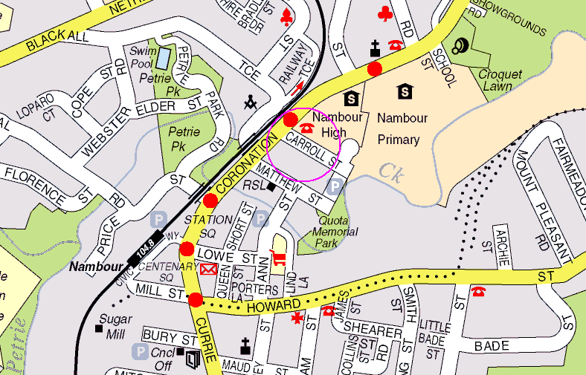

BENDIGO BANK SPONSORED SHOW

MAJOR AWARDS
CHAMPION YOUNG BIRD OF SHOW |  |  |  |  |  |  |  | TROPHY |  |  | & $100
CHAMPION YOUNG BIRD ‘Opposite Sex’ |  |  |  |  |  |  |  | TROPHY |  |  | & $100
CHAMPION OLD BIRD OF SHOW |  |  |  |  |  |  |  | TROPHY |  |  | & $50
CHAMPION JUVENILE OF SHOW |  |  |  |  |  |  |  | TROPHY |  |  | & $50
CHAMPION JUVENILE ‘Opposite Sex’  CHAMPION NEST FEATHER OF SHOW |  |  |  |  |  |  |  | TROPHY  TROPHY |  |  | & $30  & $30
SPECIAL AWARDS  JUNIOR ENCOURAGEMENT AWARD |  |  |  |  |  |  |  | TROPHY & $20
YOUNG BIRDS | OPEN |  |  |  |  |  | INTERMEDIATE |  |  | NOVICE
BEST COCK in Class |  | Cash Prize $20 |  |  |  | Cash Prize $20 |  |  | Cash Prize $20
BEST HEN in Class |  | Cash Prize $20 |  |  |  | Cash Prize $20 |  |  | Cash Prize $20

BEST NORMAL VARIETY | Cash Prize $10 | Cash Prize $10 | Cash Prize $10
BEST SEXLINKED VARIETY | Cash Prize $10 | Cash Prize $10 | Cash Prize $10
BEST DOMINANT VARIETY | Cash Prize $10 | Cash Prize $10 | Cash Prize $10
BEST RECESSIVE VARIETY | Cash Prize $10 | Cash Prize $10 | Cash Prize $10
BEST AOC/AOV and CREST | Cash Prize $10 | Cash Prize $10 | Cash Prize $10

OLD BIRDS: | OPEN | INTERMEDIATE | NOVICE
BEST in Class | Cash Prize $20 | Cash Prize $20 | Cash Prize $20
BEST NORMAL VARIETY | Cash Prize $10 | Cash Prize $10 | Cash Prize $10
BEST SEXLINKED VARIETY | Cash Prize $10 | Cash Prize $10 | Cash Prize $10
BEST DOMINANT VARIETY | Cash Prize $10 | Cash Prize $10 | Cash Prize $10
BEST RECESSIVE/ AOC/AOV and CREST (combined) | Cash Prize $10 | Cash Prize $10 | Cash Prize $10
JUVENILE BIRDS: | OPEN | INTERMEDIATE | NOVICE
BEST COCK in Class  BEST HEN in Class | Cash Prize $20  Cash Prize $20 | Cash Prize $20  Cash Prize $20 | Cash Prize $20  Cash Prize $20
BEST NORMAL VARIETY | Cash Prize $10 | Cash Prize $10 | Cash Prize $10
BEST SEXLINKED VARIETY | Cash Prize $10 | Cash Prize $10 | Cash Prize $10
BEST DOMINANT VARIETY | Cash Prize $10 | Cash Prize $10 | Cash Prize $10
BEST RECESSIVE/ AOC/AOV and CREST (combined) | Cash Prize $10 | Cash Prize $10 | Cash Prize $10
NESTFEATHER: | OPEN | INTERMEDIATE |  | NOVICE
(UNISEX )
BEST in class | Cash Prize $20 | Cash Prize $20 | Cash Prize $20
BEST NORMAL VARIETY | Cash Prize $10 | Cash Prize $10 | Cash Prize $10
BEST SEXLINKED VARIETY | Cash Prize $10 | Cash Prize $10 | Cash Prize $10
BEST DOMINANT VARIETY | Cash Prize $10 | Cash Prize $10 | Cash Prize $10
BEST RECESSIVE/ AOC/AOV and CREST (combined) | Cash Prize $10 | Cash Prize $10 | Cash Prize $10
NOTE:

(all NestFeather Cocks & Hens- please use unisex odd numbering on Entry Form ie: right hand column only.

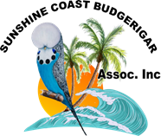

GOLD BREEDERS SECTION AWARDS:

GBA CERTIFICATE WILL BE AWARDED TO BEST YOUNG BIRD IN EACH VARIETY

- NORMAL GREEN |  | 15. DOMINANT PIED
- NORMAL GREY GREEN |  | 16. NORMAL SPANGLE
- NORMAL BLUE |  | 17. SPANGLE AOSV
- NORMAL VIOLET |  | 18. SPANGLE Double Factor
- NORMAL GREY |  | 19. GREYWING
6. YELLOW FACE NORMAL 20. CLEARWING
7. AUST GOLDEN FACE NORMAL 21. FALLOW
8. LUTINO 22. BLACK EYED SELF
9. ALBINO 23. DILUTE
10. CINNAMONWING 24. RECESSIVE PIED
11. LACEWING 25. DARK EYED CLEAR
12. NORMAL OPALINE 26. CRESTED
13. OPALINE AOSV 27. SADDLEBACK/DARKWING
14. CLEARBODY 28. AUST WHITE CAP

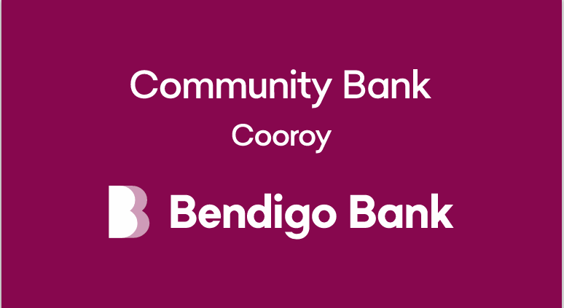

SQBBA COLOUR SCHEDULE
Cocks |  |  | As at 1/1/2021 |  |  |  |  |  |  |  |  |  | Hens
No |  | Old |  | Y/B | N/F | JUV | VARIETY | COLOUR |  | Old | Y/B | N/F | JUV | No.
1 |  |  |  |  |  |  | Normal | Light Green |  |  |  |  |  | 2
3 |  |  |  |  |  |  | Normal | Dark or Olive Green |  |  |  |  |  | 4
5 |  |  |  |  |  |  | Normal | Grey Green |  |  |  |  |  | 6
7 |  |  |  |  |  |  | Normal | Sky Blue |  |  |  |  |  | 8
9 |  |  |  |  |  |  | Normal | Cobalt, Mauve, Violet Sky, Violet Mauve |  |  |  |  |  | 10
11 |  |  |  |  |  |  | Normal | Violet |  |  |  |  |  | 12
13 |  |  |  |  |  |  | Normal | Grey |  |  |  |  |  | 14
15 |  |  |  |  |  |  | Yellowface Normal | Blue Series |  |  |  |  |  | 16
17 |  |  |  |  |  |  | Australian Golden Face Normal (Double Factor only) | Blue Series |  |  |  |  |  | 18
19 |  |  |  |  |  |  | Australian Golden Face Normal (Single Factor only) | Blue Series |  |  |  |  |  | 20
21 |  |  |  |  |  |  | Lutino | Yellow |  |  |  |  |  | 22
23 |  |  |  |  |  |  | Albino (incl Y/face & Golden Face) | White |  |  |  |  |  | 24
25 |  |  |  |  |  |  | Cinnamonwing (incl Y/face & Golden Face) | Green or Blue Series |  |  |  |  |  | 26
27 |  |  |  |  |  |  | Lacewing (incl Y/face, Golden Face & Opaline ) | Green or Blue Series |  |  |  |  |  | 28
29 |  |  |  |  |  |  | Opaline Normal (incl Y/face & Golden Face) | Green or Blue Series |  |  |  |  |  | 30
31 |  |  |  |  |  |  | Opaline AOSV (incl Y/face, Golden Face, Blackeye, Dilute, Clearwing, Greywing, Cinnamon ) | Green or Blue Series |  |  |  |  |  | 32
33 |  |  |  |  |  |  | Clearbody Normal (incl Y/face & Golden Face & Opaline) | Green or Blue Series |  |  |  |  |  | 34
35 |  |  |  |  |  |  | Dominant Pied (incl D/Factor, Y/face, Golden Face, Greywing, Cinnamon, Opaline, Fallow & Spangle) | Green or Blue Series |  |  |  |  |  | 36
37 |  |  |  |  |  |  | Spangle Normal (Incl Y/face & Golden Face, Excl Pied & all in Spangle AOSV ) | Green or Blue Series |  |  |  |  |  | 38
39 |  |  |  |  |  |  | Spangle AOSV (incl Greywing, Cinn, Opal & Fallow & combinations & incl Y/Face, Golden Face) | Green or Blue Series |  |  |  |  |  | 40
41 |  |  |  |  |  |  | Spangle Double Factor - (incl Y/face & Golden Face) | Green or Blue Series |  |  |  |  |  | 42
43 |  |  |  |  |  |  | Australian Whitecap - Single & Double Factor  including all varieties in blue series except Yellowface, Goldenface and Crest | Blue Series |  |  |  |  |  | 44
45 |  |  |  |  |  |  | Greywing Normal (excl Opal, Cinn) (incl Y/face & Golden Face) | Green or Blue Series |  |  |  |  |  | 46
47 |  |  |  |  |  |  | Clearwing Normal(excl Opal, Cinn) (incl Y/face & Golden Face) | Green or Blue Series |  |  |  |  |  | 48
49 |  |  |  |  |  |  | Fallow (incl Y/face, Golden Face, Greywing &Opaline ) | Green or Blue Series |  |  |  |  |  | 50
51 |  |  |  |  |  |  | Blackeye Self Normal (excl Opaline) (incl Y/face & Golden Face) | Green or Blue Series |  |  |  |  |  | 52
53 |  |  |  |  |  |  | Dilute Normal (excl Opaline) (incl Grey Yellow/White, Y/face & Golden Face) | Green or Blue Series |  |  |  |  |  | 54
55 |  |  |  |  |  |  | Danish Recessive Pied (incl Y/face, Golden Face,  Greywing, Cinnamonwing, Opaline, Fallow & Spangle) | Green or Blue Series |  |  |  |  |  | 56
57 |  |  |  |  |  |  | Dark Eyed Clear (incl Y/face & Golden Face) | Green or Blue Series |  |  |  |  |  | 58
59 |  |  |  |  |  |  | Crested ASV (incl Y/face & Golden Face) | Green or Blue Series |  |  |  |  |  | 60
61 |  |  |  |  |  |  | Saddleback ASV (incl Y/facw & Golden face) | Green or Blue Series |  |  |  |  |  | 62
63 |  |  |  |  |  |  | Darkwing ASV (incl Y/facw & Golden face) | Green or Blue Series |  |  |  |  |  | 64
65 |  |  |  |  |  |  | AOSV Any Other Standard Variety | Green or Blue Series |  |  |  |  |  | 66
* When placing entries please ensure you state whether Any Age, Old, Young, Nestfeather or Juvenile birds are being entered.
* Green Series includes Light, Dark, Olive and Grey Green.
* Blue Series includes Skyblue, Cobalt, Mauve, Violet and Grey.
* All classes are in accordance with the ANBC Standard and Matrix - Amendment 1 of 2012
* Multiple factor birds exist in many combinations. Therefore , if the schedule does not list a certain colour/variety combination then these birds will go into the AOV and Non Standardised classes. Refer ANBC Standard colour matrix for combinations.
* Variable class to be nominated on the Show Schedule by each club as required.

VARIETIES:

Normal classes-1 to 20, Sexlinked-21 to 34, Dominant-35 to 44, Recessive-45 to 58, AOV/Crest-59 to 66
BENDIGO BANK SPONSORED SHOW

SCBA Inc SHOW ENTRY FORM Show Date 19/ 7/2026 EXHIBITOR'S NAME
CLASS  No. |  | OLD BIRDS  (OB) | YOUNG BIRDS  (YB) |  | JUVENILE  BIRDS  (JB) | N’FEATHER  (NF) use ODD # only | CLASS  No. NF  only
1 |  |  |  |  |  |  | 1 | PHONE No.
2 |  |  |  |  |  |  | -
3 |  |  |  |  |  |  | 3
4 |  |  |  |  |  |  | -
5 |  |  |  |  |  |  | 5 | EMAIL ADDRESS:
6 |  |  |  |  |  |  | -
7 |  |  |  |  |  |  | 7
8 |  |  |  |  |  |  | - | ………………………………………………….
9 |  |  |  |  |  |  | 9 | ADDRESS:
10 |  |  |  |  |  |  | -
11 |  |  |  |  |  |  | 11 | …………………………………………………..
12 |  |  |  |  |  |  | - | POSTCODE:
13 |  |  |  |  |  |  | 13
14 |  |  |  |  |  |  | - | X in bracket which is applicable
15 |  |  |  |  |  |  | 15
16 |  |  |  |  |  |  | - | BREEDERS STATUS
17 |  |  |  |  |  |  | 17 | OPEN ( )
18 |  |  |  |  |  |  | -
19 |  |  |  |  |  |  | 19 | INTERMEDIATE ( )
20 |  |  |  |  |  |  | -
21 |  |  |  |  |  |  | 21 | NOVICE ( )
22 |  |  |  |  |  |  | -
23 |  |  |  |  |  |  | 23 | JUNIOR ( )
26 |  |  |  |  |  |  | -
27 |  |  |  |  |  |  | 27 | TOTAL No. BIRDS
28 |  |  |  |  |  |  | - | ENTERED ……………
29 |  |  |  |  |  |  | 29
30 |  |  |  |  |  |  | - | AMOUNT OWING
31 |  |  |  |  |  |  | 31 | FOR ENTRIES $ …………....
32 |  |  |  |  |  |  | -
33 |  |  |  |  |  |  | 33 | MAXIMUM $.....................
37 |  |  |  |  |  |  | 37 | COLLECT STICKERS ( )
38 |  |  |  |  |  |  | - | (OUR PREFERRED OPTION)
39 |  |  |  |  |  |  | 39
40 |  |  |  |  |  |  | - | POST STICKERS ( )
41 |  |  |  |  |  |  | 41 | Add $2 for postage costs
42 |  |  |  |  |  |  | -
43 |  |  |  |  |  |  | 43
44 |  |  |  |  |  |  | - | TOTAL OWING $ ………………….
45 |  |  |  |  |  |  | 45
47 |  |  |  |  |  |  | 47 | AVAILABLE TO HELP DURING SHOW eg.
48 |  |  |  |  |  |  | - | STEWARD,  PENCILLER
51 |  |  |  |  |  |  | 51 | LUNCH $7.00ea No. ………
52 |  |  |  |  |  |  | - | HELP SET UP STAGING SAT ( )
54 |  |  |  |  |  |  | - | COMMENTS  NOTE TO EXHIBITORS
55 |  |  |  |  |  |  | 55 | Please fill in your details and mark with ( X ) in brackets.  When completed save and close this attachment and send back to sender. (return email icon, top left hand side of this email.
56 |  |  |  |  |  |  | -
58 |  |  |  |  |  |  | -
59 |  |  |  |  |  |  | 59
60 |  |  |  |  |  |  | -
61 |  |  |  |  |  |  | 61
62 |  |  |  |  |  |  | -
63 |  |  |  |  |  |  | 63
64 |  |  |  |  |  |  | - | ENTRY ENTERED IN SM ...................
65 |  |  |  |  |  |  | 65 | ENTRY ENTERED IN SM ...................

VARIETIES:

Normal classes-1 to 20, Sexlinked-21 to 34, Dominant-35 to 44, Recessive-45 to 58, AOV/Crest-59 to 66
BENDIGO BANK SPONSORED SHOW

