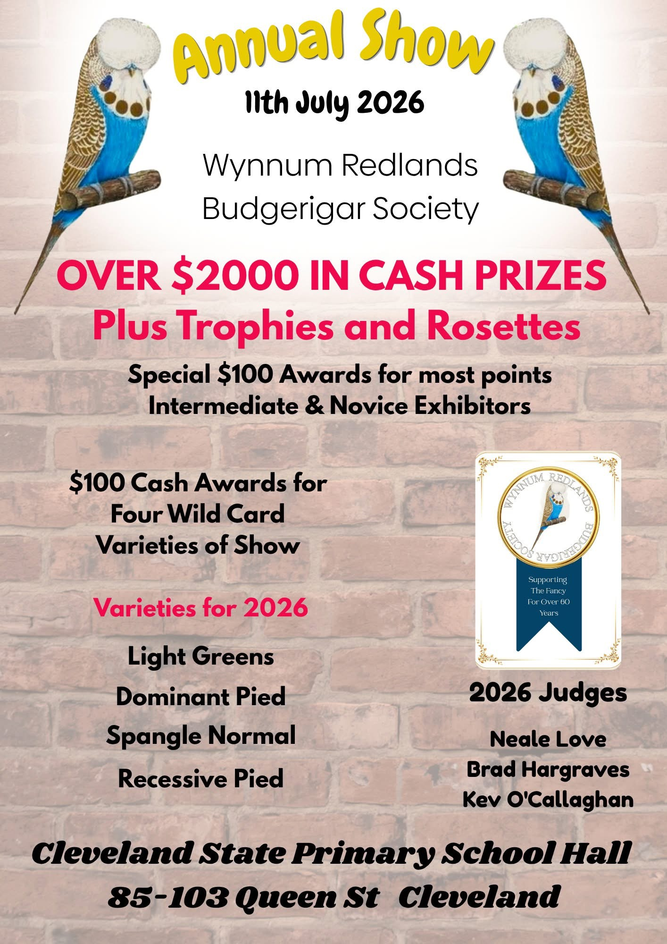
Wynnum Redlands Budgerigar Society Annual Show
11th July 2026

For: Old Birds Young Birds Juvenile Birds & Nestfeathers
Cleveland State Primary School Hall
85-103 Queen St Cleveland

All Birds to be bred by the Exhibitor (no purchased birds to be shown)
Young Birds to be rung with an approved 2025 closed ring (black)& bred by the Exhibitor. Juvenile & Nestfeathers to be rung with an approved 2026 closed ring (green) & bred by the Exhibitor.
Juvenile birds must have full adult plumage.
Staging from 7.30 am with final staging 8.30am
Judging commences at 9am
Entries close: Monday 6th July at 8pm
Online entries to: https://wrbs.fairwire.com
Phone entries to: Pat Sedgwick. Phone entries will be accepted up to 8 pm on that date
Call Pat on 07 33968732 Mobile: 0413 960 396 or email: billsed@tpg.com.au
Exhibitors are requested to enter birds in the following sections:
Old Birds, Young Birds, Juvenile Birds enter as Cocks & Hens.
Nestfeathers are unisex, please use the cock column for entry numbers (odd numbers)
Please note that due to computerized entry system it is difficult to reclassify any entries.
Entry fee: $1 per bird to Maximum of $10. Please note: all birds entered must be paid for.
All stickers to be collected at the show. NO POSTAGE
Cages: Only ANBC approved cages accepted, please ensure drinkers are in correct position
The cage must be in good clean condition. Ensure perches & door are secure.
Floor covering: Millet sprays NO Seed.
Trophies: To be presented once judging is completed.
*Best Young Dominant Pied – Mal Lawn Memorial Trophy*

AWARD |  | PRIZE | AWARD |  |  | TROPHY
Champion Young Cock of Show |  | Sash & $100 | Best WRBS Rung Bird of Show |  |  | Trophy & $30
Champion Young Hen of Show |  | Sash & $100 | Best WRBS Rung Nestfeather of Show |  |  | Trophy & $30
Champion Old Cock of Show |  | Sash & $30 | Best Junior Old Bird of Show |  |  | Trophy
Champion Old Hen of Show |  | Sash & $30 | Best Junior Juvenile Bird of Show |  |  | Trophy
Champion Juvenile Cock of Show |  | Sash & $30 | Best Junior Young Bird of Show |  |  | Trophy
Champion Juvenile Hen of Show |  | Sash & $30 | Best Junior Nestfeather of Show |  |  | Trophy
Champion Nestfeather of Show |  | Sash & $30
Open, Intermediate & Novice |  |  | Open, Intermediate & Novice
Best Old Cock |  | $20 | Best Juvenile Cock |  |  | $20
Best Old Hen |  | $20 | Best Juvenile Hen |  |  | $20
Best Young Cock |  | $20 | Best Nestfeather |  |  | $20
Best Young Hen |  | $20
$15 prize will be awarded in Open, Intermediate and Novice for each of the following sections
Old | Young |  |  | Juvenile | Nestfeather
Normal | Normal |  |  | Normal | Normal
Sexlinked | Sexlinked |  |  | Sexlinked | Sexlinked
Dominant | Dominant |  |  | Dominant | Dominant
Recessive | Recessive |  |  | Recessive | Recessive
Morning tea will be provided. Lunch will be available at a nominal cost
Removal of birds immediately after presentation of trophies.
Every care will be taken with the exhibits, but WRBS will not be responsible for any losses, deaths, or accidents. The Show will be conducted in accordance with the Show Rules of SQBBA & adopted by WRBS.
