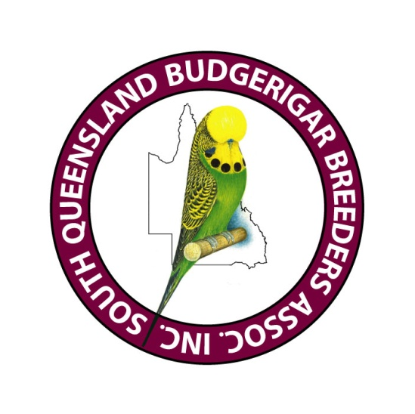

South Queensland Budgerigar Breeders Association inc.
ABN 75324005858
Garry Jones
Show Manager
Ph 0403 424701
11/4/2026

Dear Secretary
The Zone Selection Show to select the Show team for this year’s Nationals will be held at the Strathpine Community Centre, Tom Petrie Room, off Mecklem Street (Cnr Gympie Road) Strathpine

Staging of the team can commence from 7.30 once the club’s complete team is present and be completed no later than 8:00 am. Club teams are to be benched as a complete unit with judging to commence at 8:30 am, NO LATE BENCHING WILL BE ACCEPTED AFTER JUDGING HAS COMMENCED.

Coffee and tea will be provided.
Lunch will be available at a reasonable cost.

Your Club is invited to enter a team of birds to participate in this selection show.
Club teams to consist of up to four birds in every class provided for in the ANBC National show schedule. Clubs also to advise a team manager for the day and also provide at least 1 steward, and please advise who this will be.

Clubs are also requested to enter birds in the Variable class which will be for demonstration purposes at the Nationals. Birds in this class will be Darkwings, Saddlebacks and Rainbows.

Please advise me as soon as possible if your Club will or will not participate in the show.

The entry fee of $50 paid via direct deposit to SQBBA – BSB 638 070 account 013436910 and notify the Treasurer Heather Farren-Price arthurfp@bigpond.com or mobile 0407 374881or 5429 8930 once deposited, should accompany your acceptance advice.
Stewards are required to assist with staging and shifting of the birds during judging, please advise me who will be available from your Club to assist.

Regards
Garry Jones
Show Manager
garryj24@gmail.com
0403 424 701

